# Installing "OpenLayers" plugin

Start "QGIS", then the following QGIS window will be popped up.

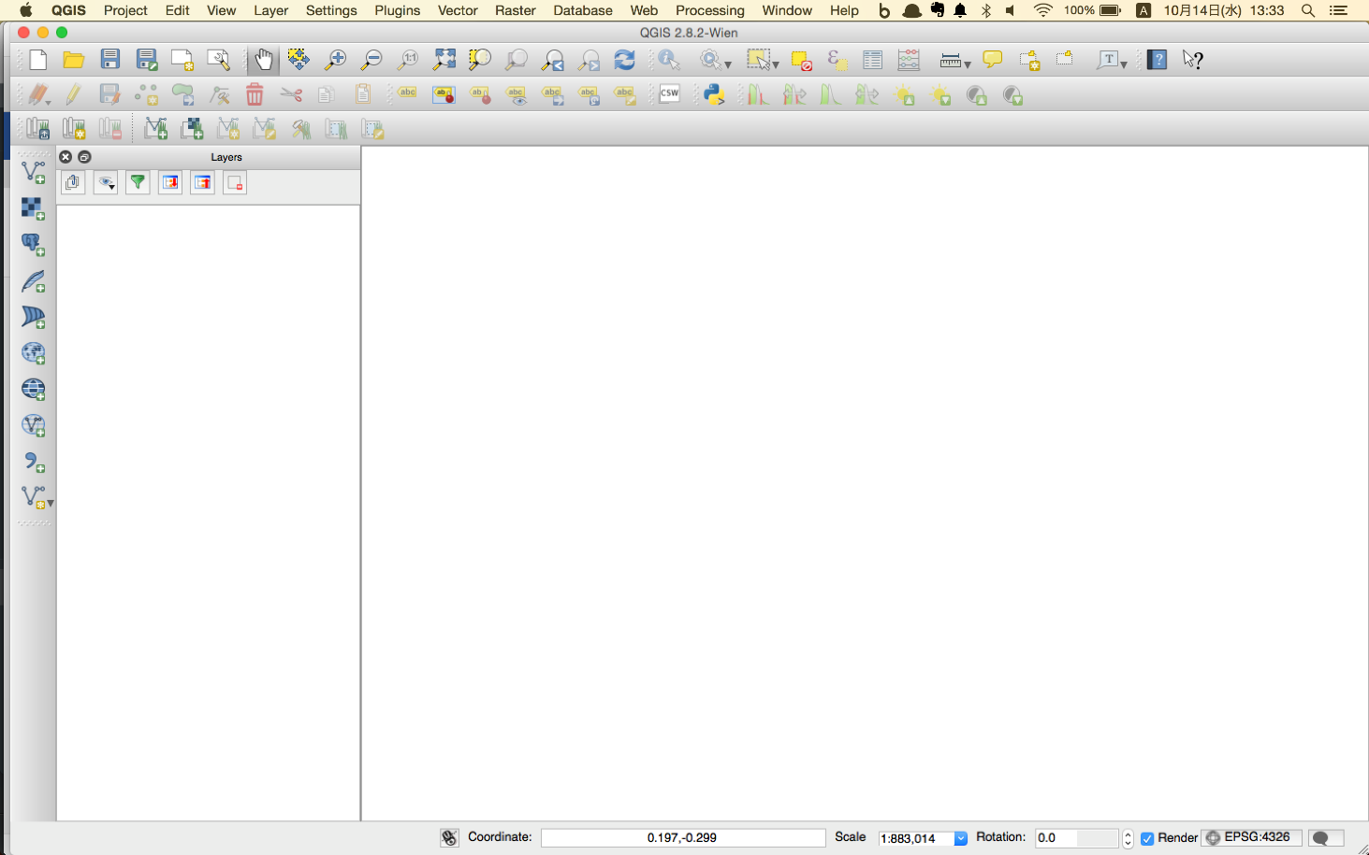

Click "Plugins" tab and select "Manage and Install Plugins..."

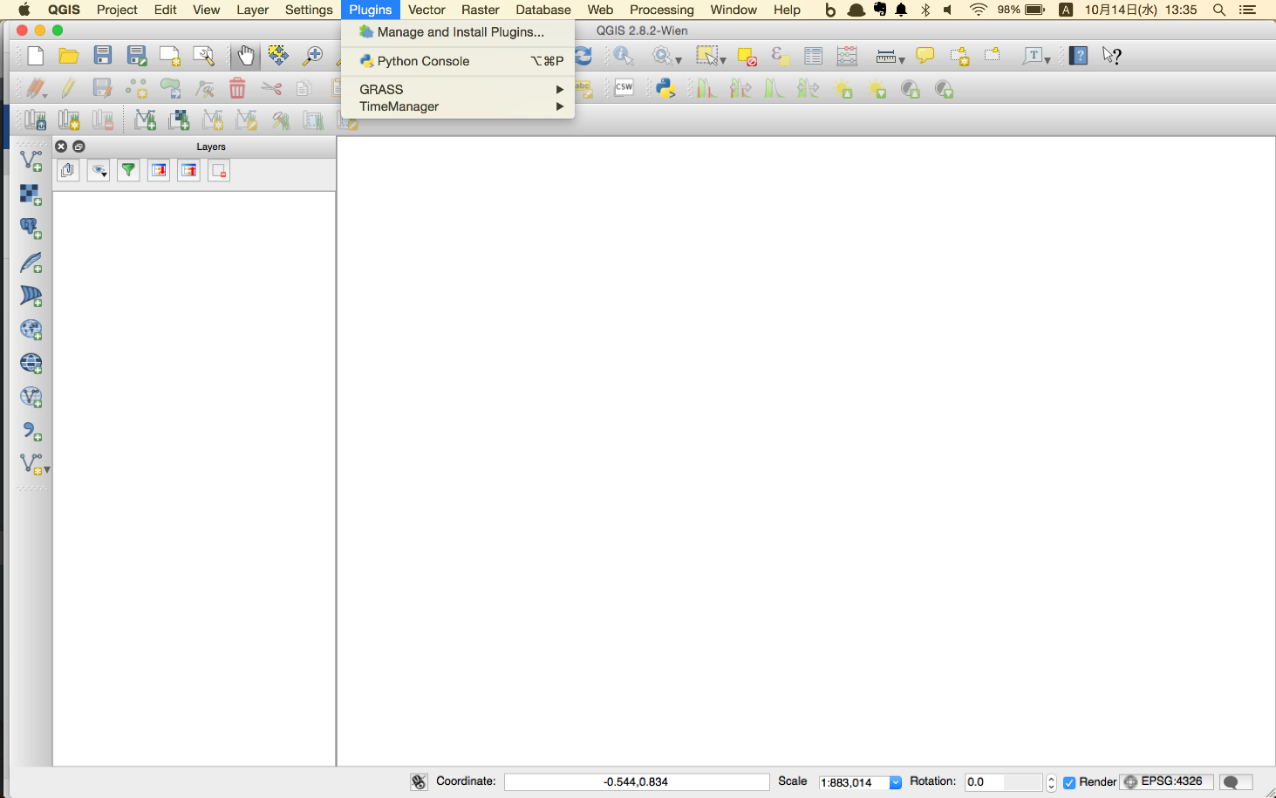

Search "OpenLayers" in the "Search" box and find "OpenLayers Plugin". Click "Install Plugin", then install "OpenLayers Plugin"

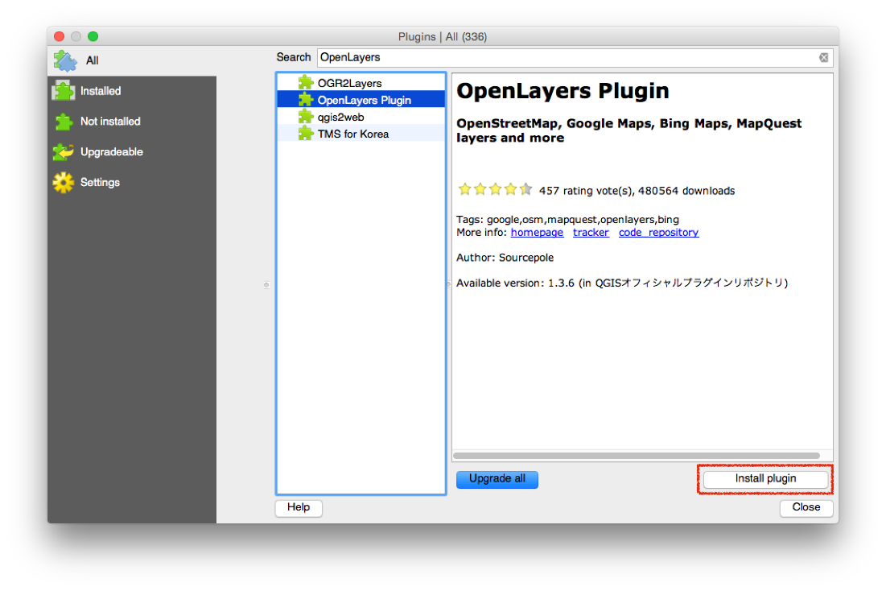

# Open working project

Click "Project" tab and select "Open...". Chose QGIS project file "village_project.qgs"

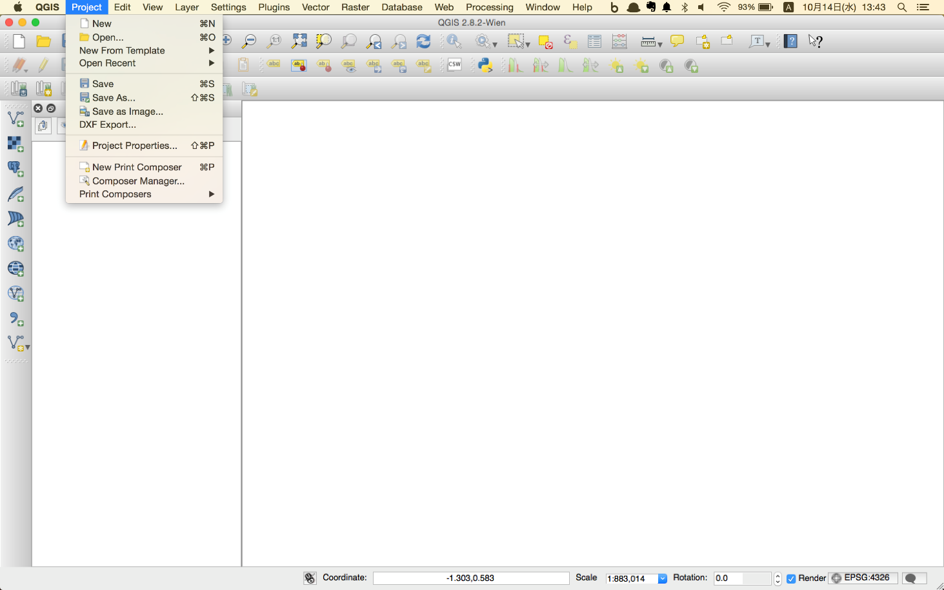

You will find the following interface.

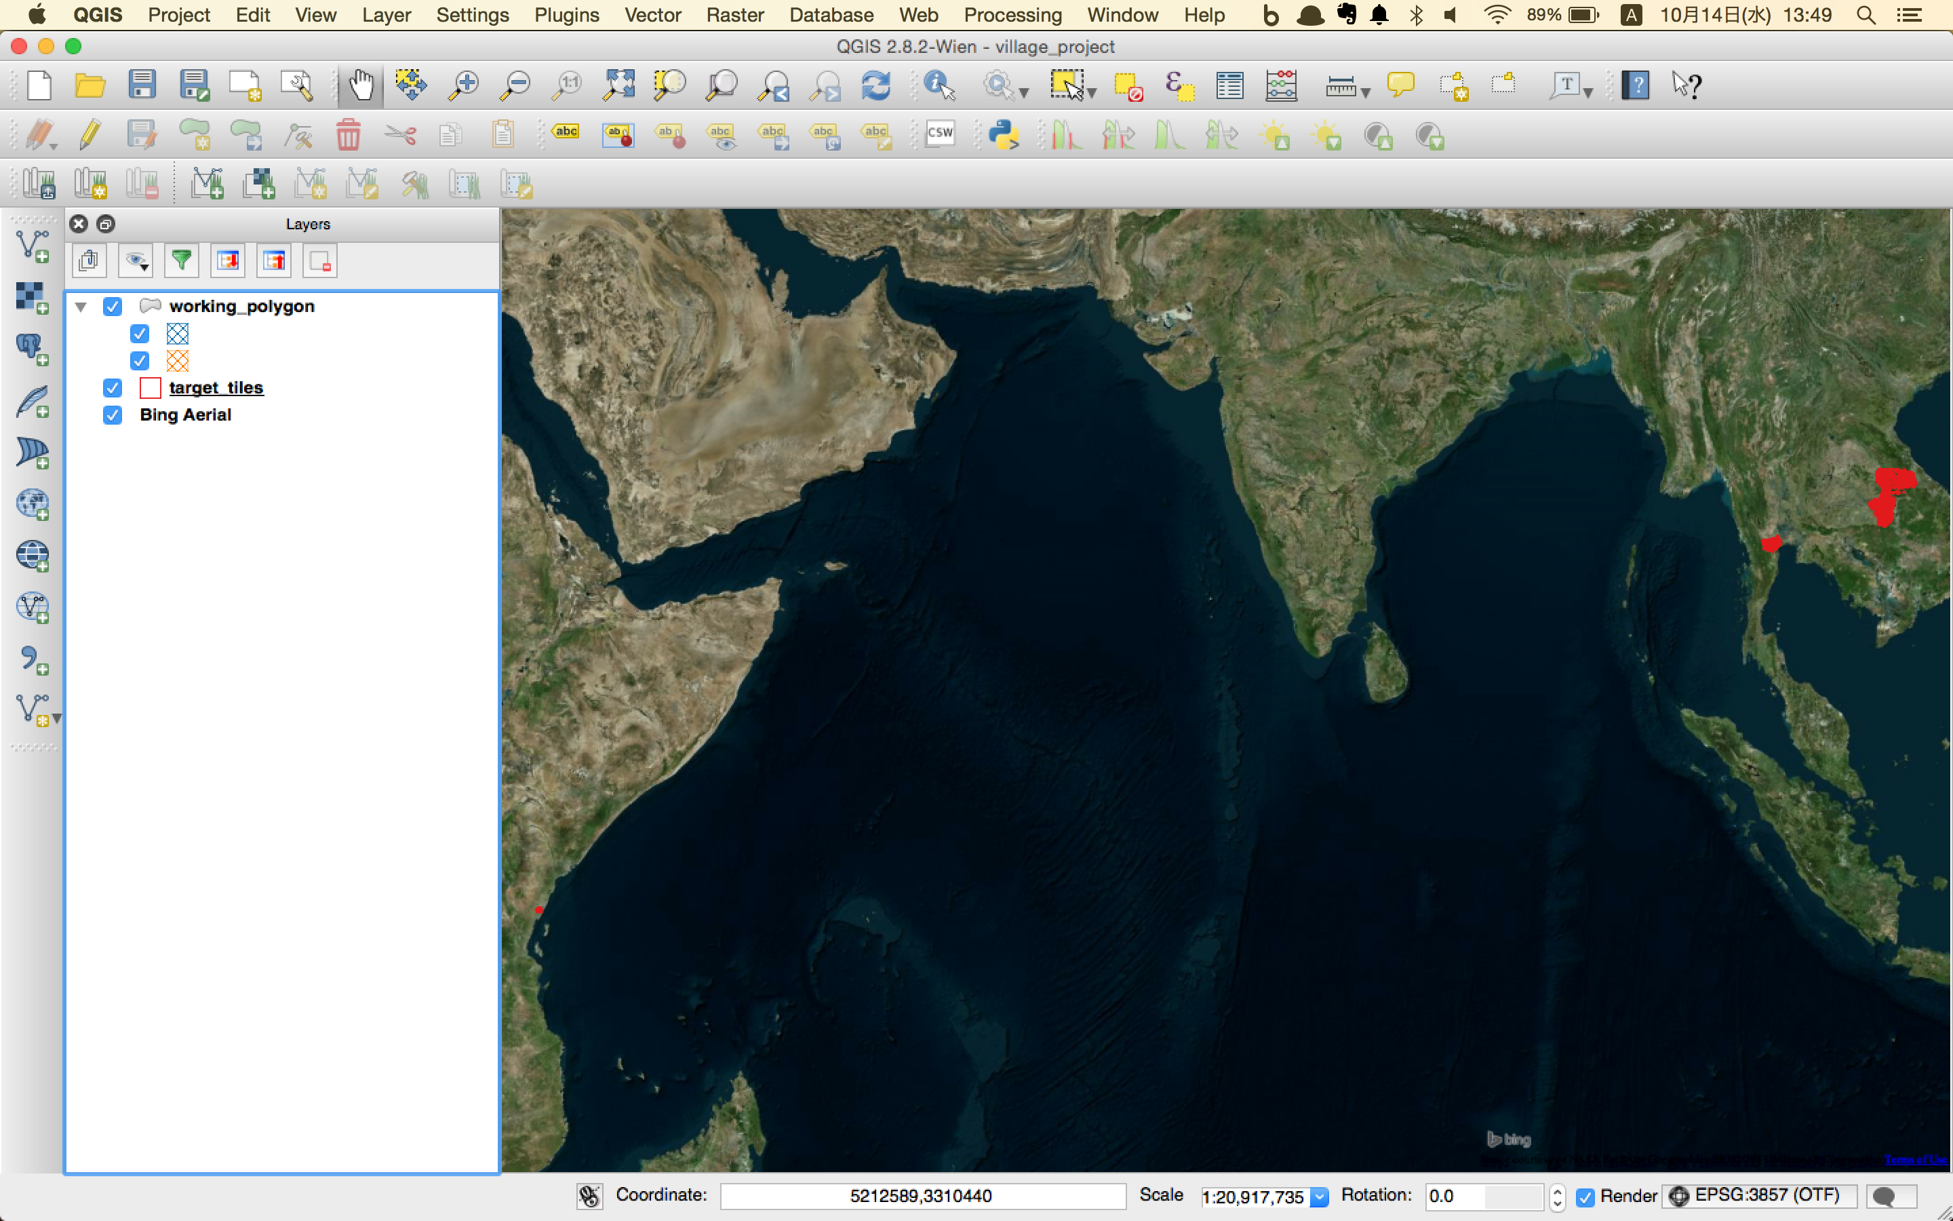

# Digitize "building" or "Unknown" features

The diagram below shows the flow of digitizing.

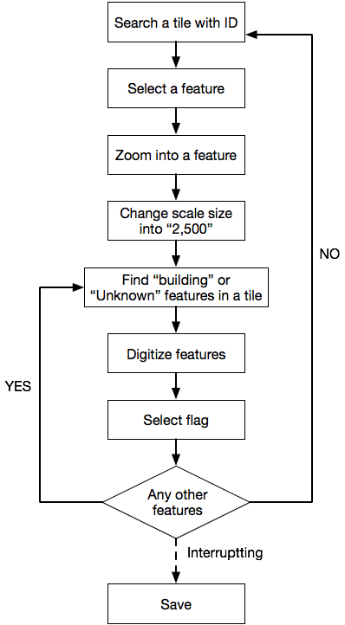

## Search a tile with ID

1. Select "target_tiles" on *Layers* side window and right click. Select "Open Attribute Table".

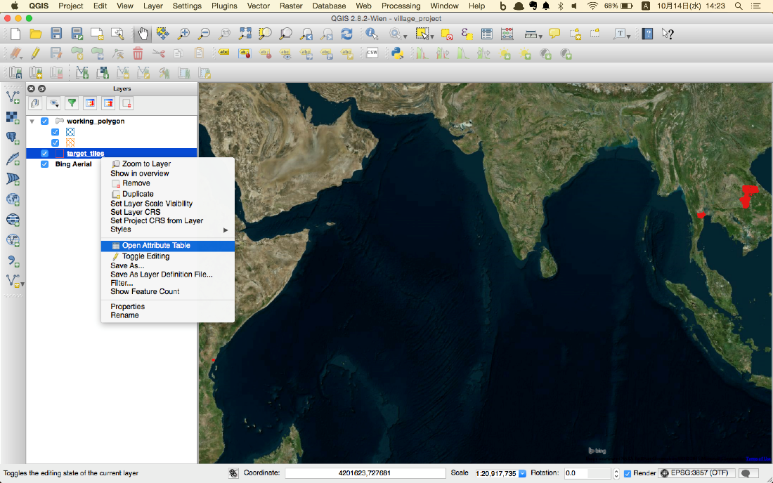

2. A new window with a table like below will be shown up.

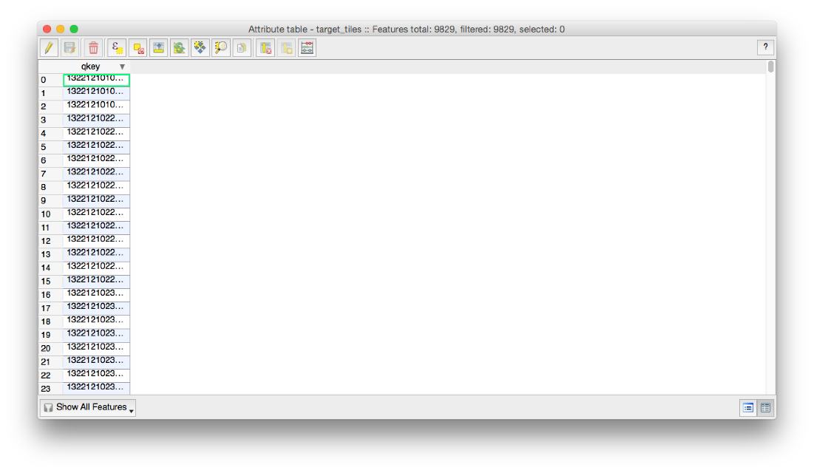

3. Select expression icon.

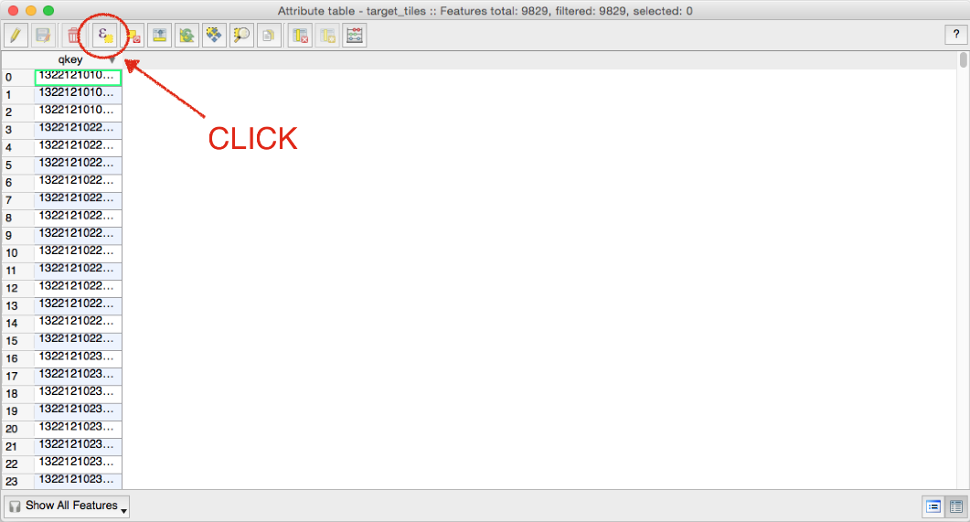

4. A new window “Select by expression – target_tiles” will be shown up.

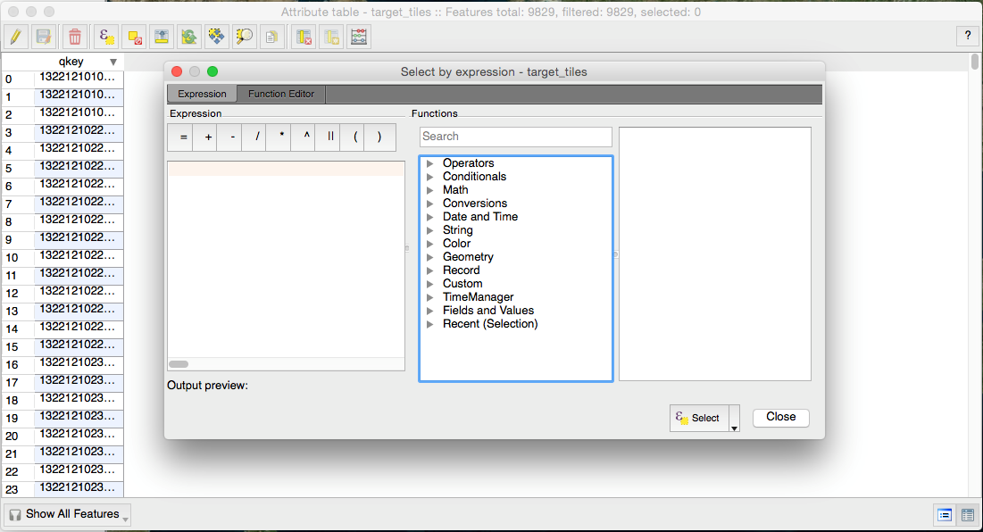

## Select a tile with ID

Input an equation like “qkey” = ‘13221210113233’ which indicates your assignments given by the manger in the expression box. Then, click "Select".

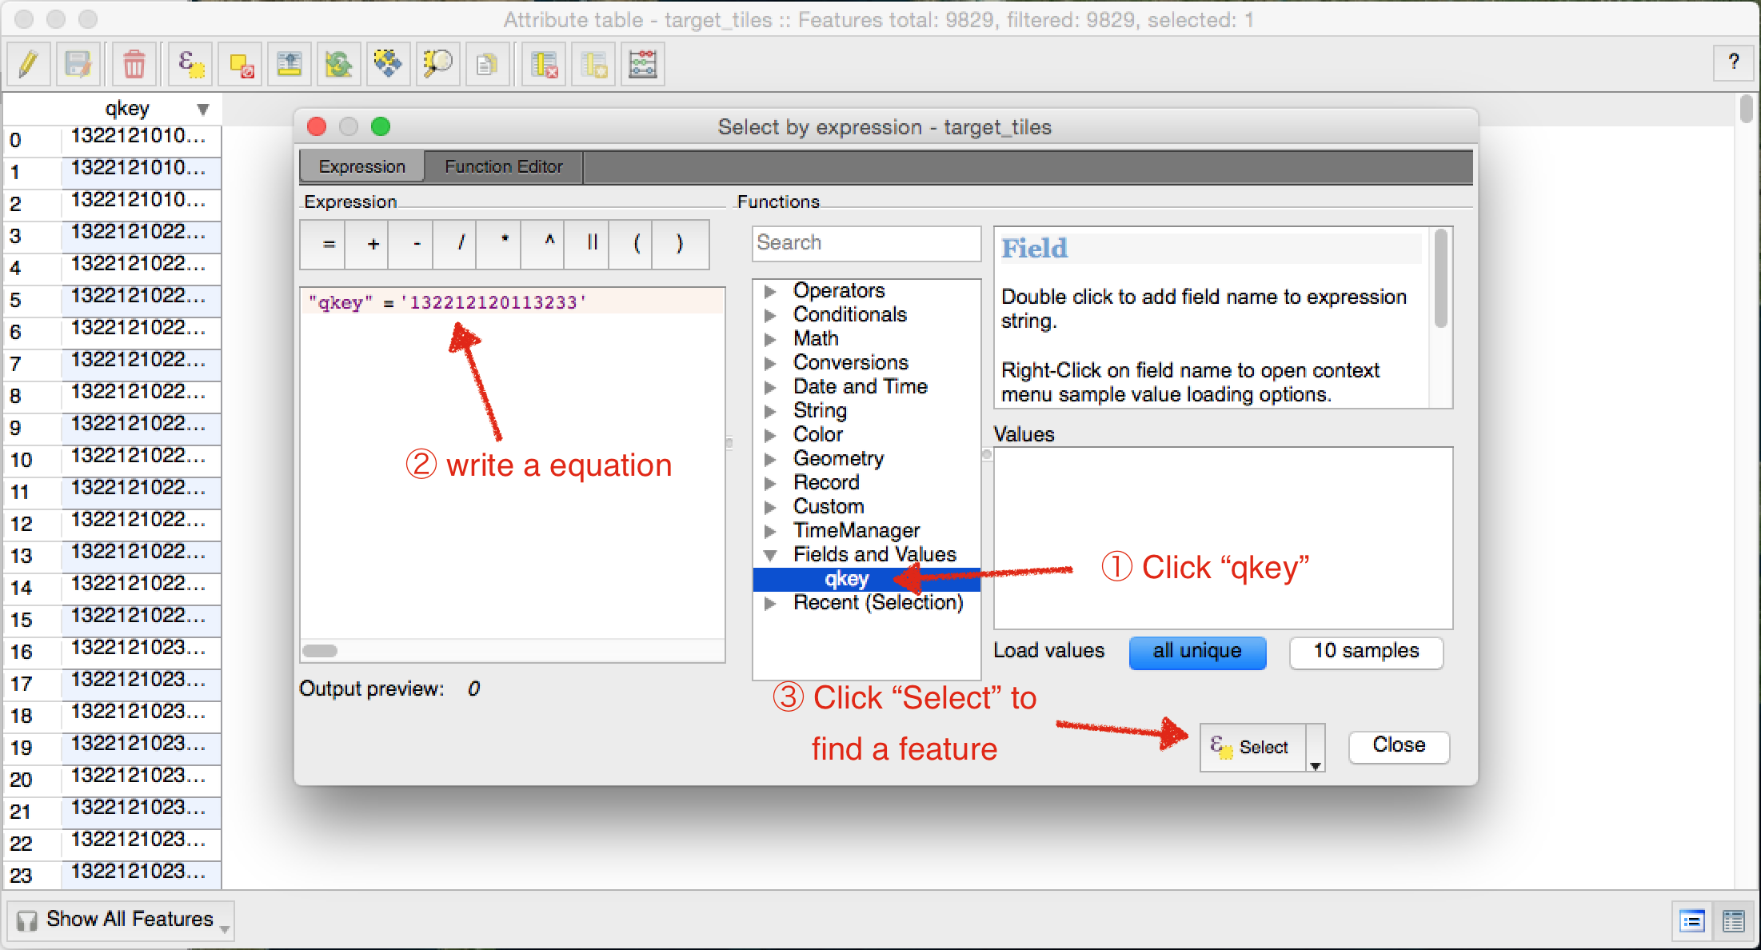

## Zoom into a feature

1. Zoom map into a selected feature.

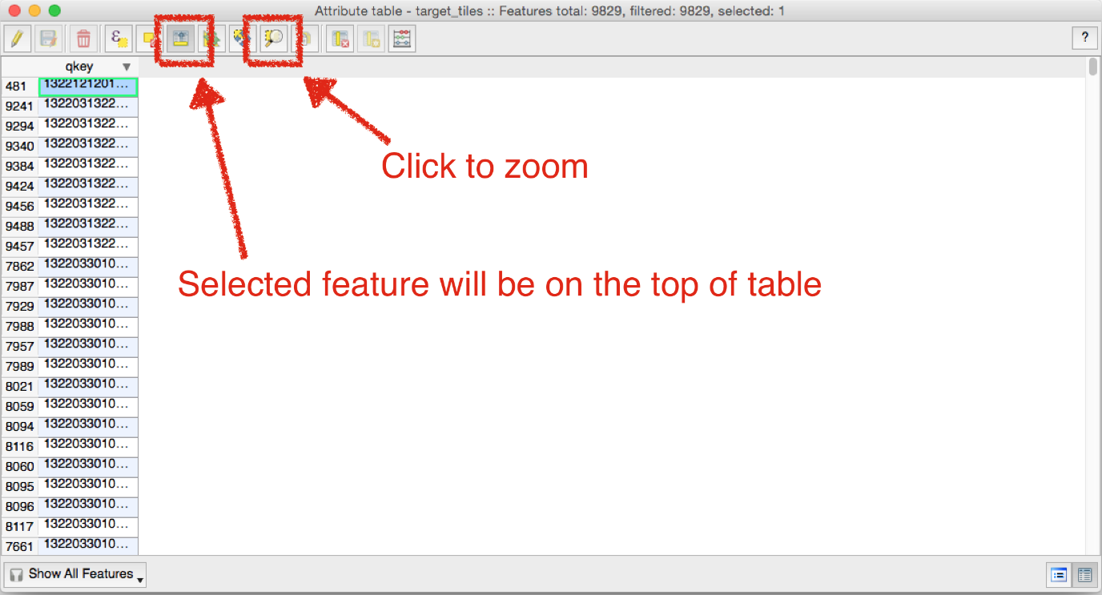

2. The map is zoomed into the selected feature.

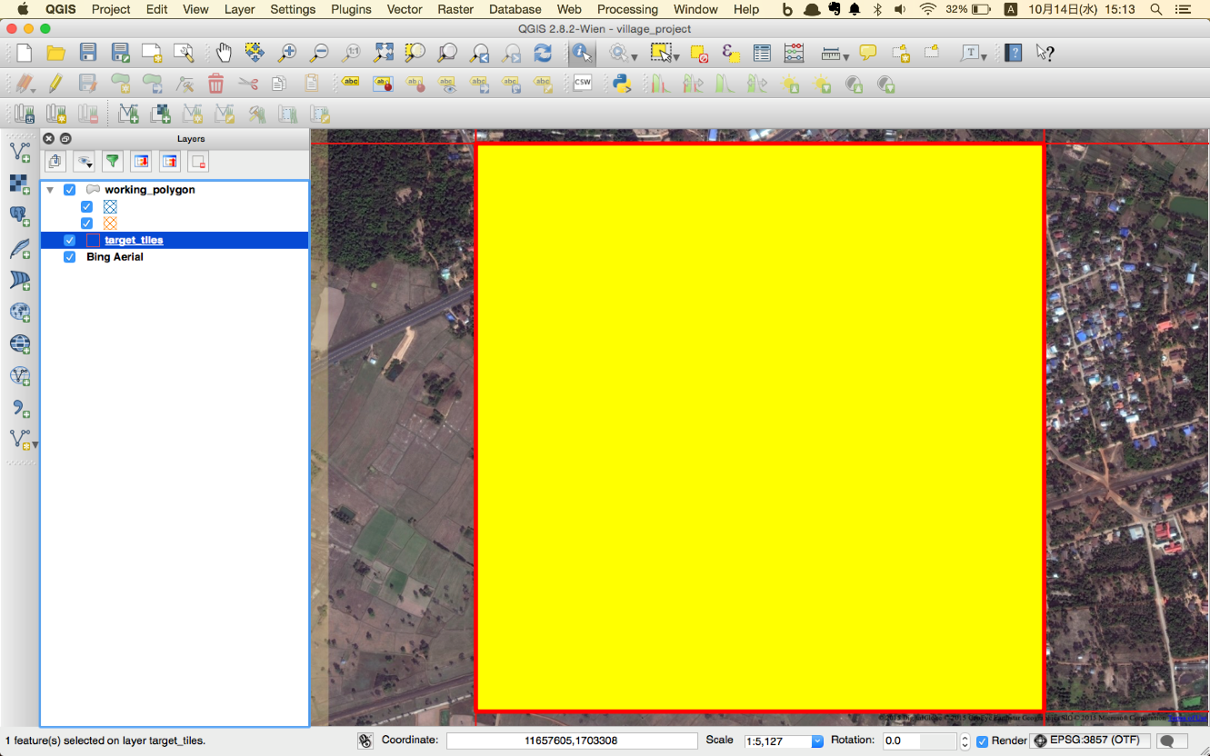

3. Unselect feature.

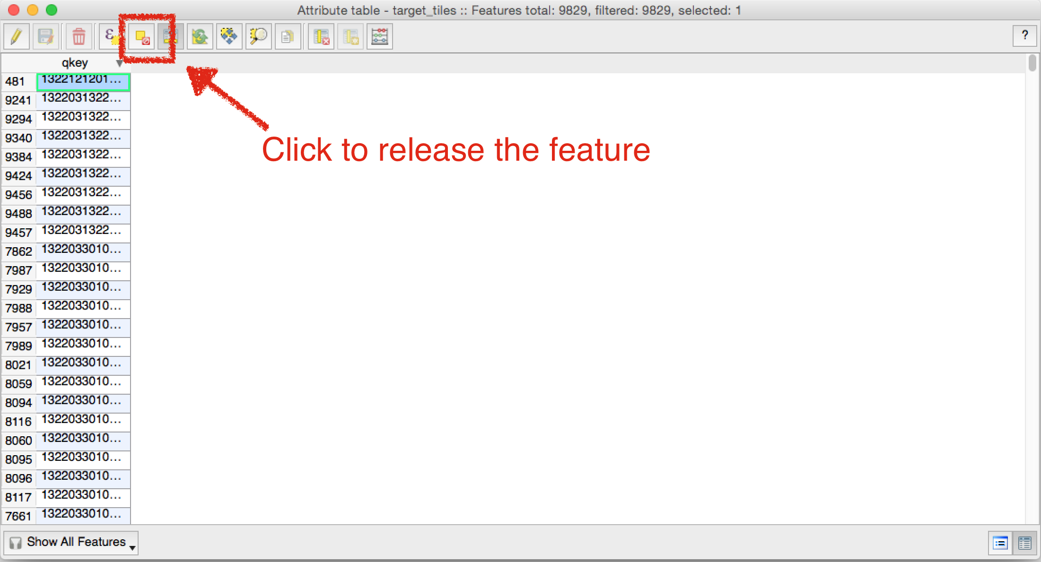

or

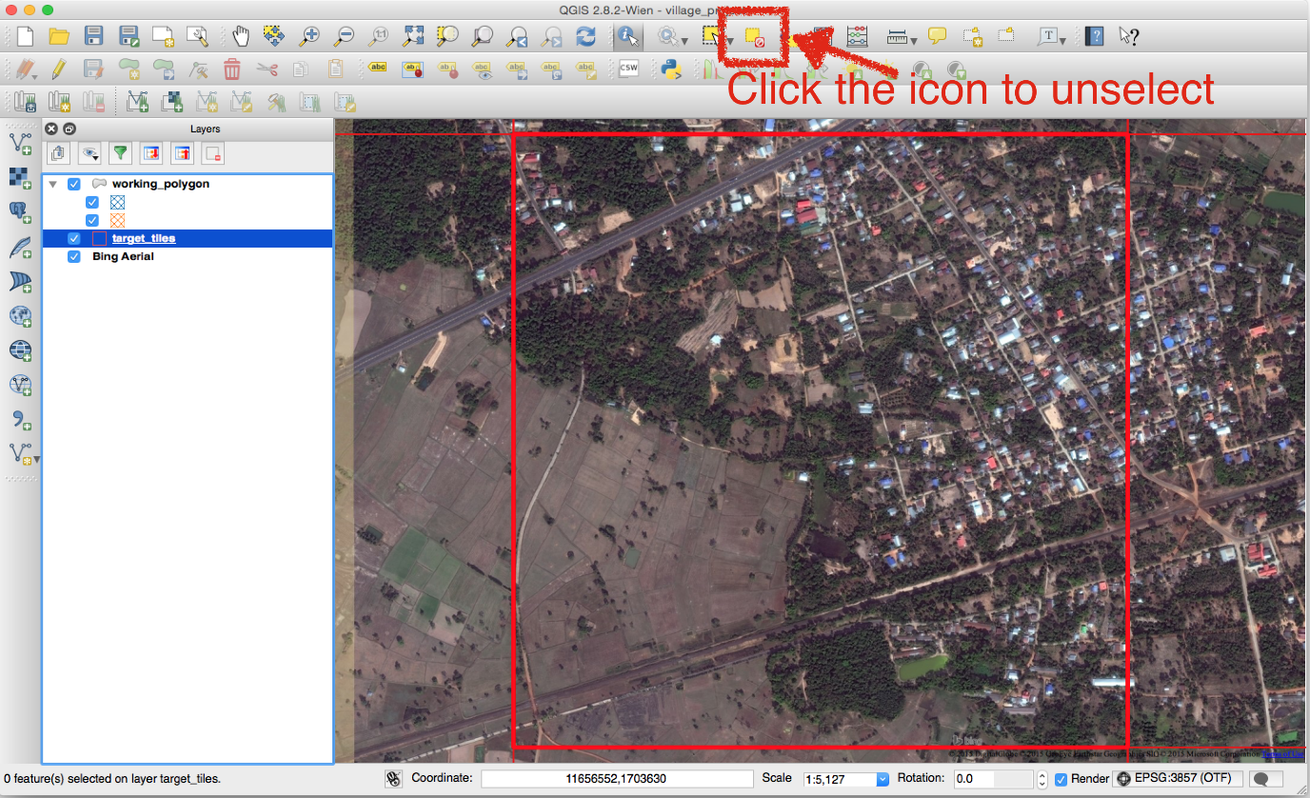

## Change map scale to 2,500

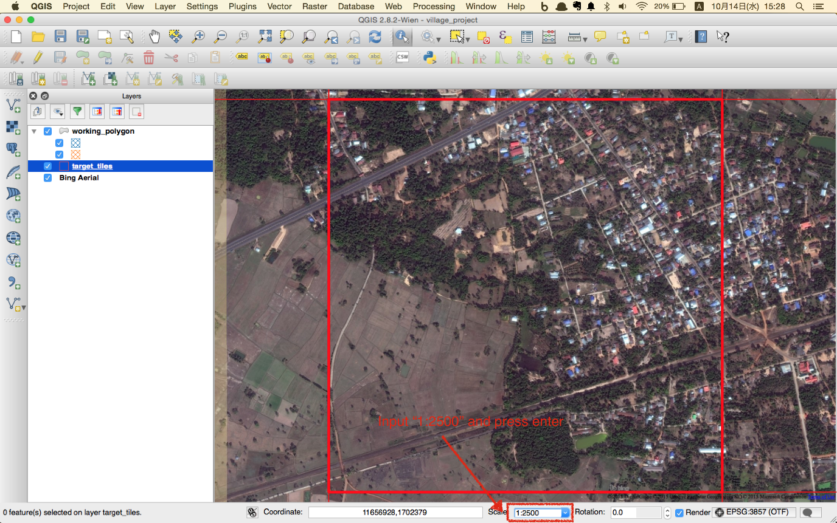

## Find “building” or “Unknown” features in a tile

1. Click the icon. It allows you to move map view by a mouce

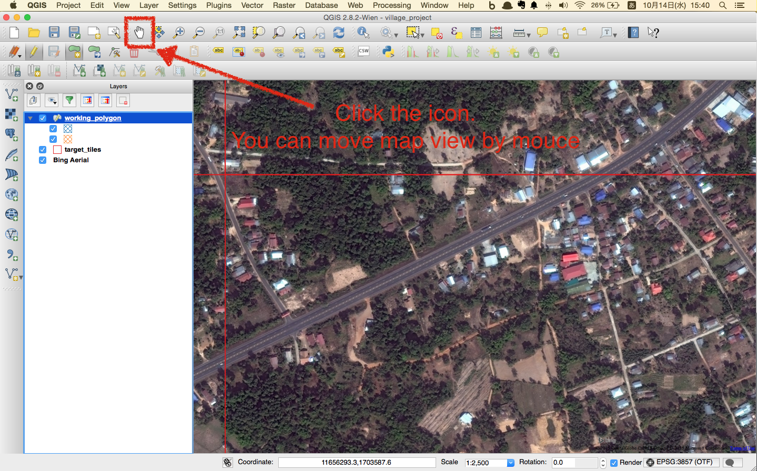

## Digitize features

1. Select "working_polygon" layer
2. Click "Editing mode" icon to switch editing mode
3. Click "Add Feature" icon to add a new feature
4. Find a building or unknown feature on the map.
5. Click vertexes of a feature to make a polygon
6. Right click to finish digitize

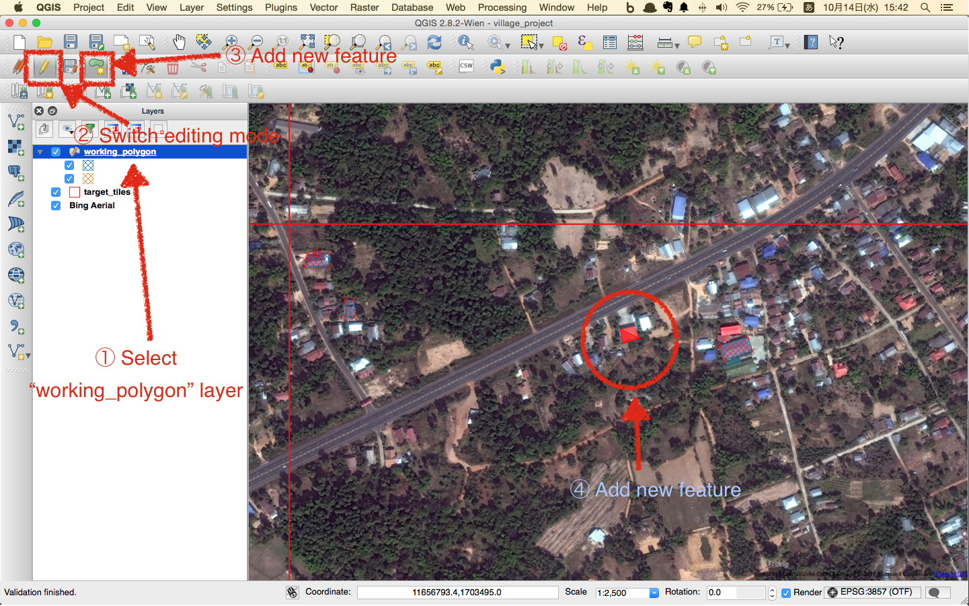

## Select flag

1. Select a flag type, "Building" or "Unknown"

2. Click "OK" to finish digitizing a feature

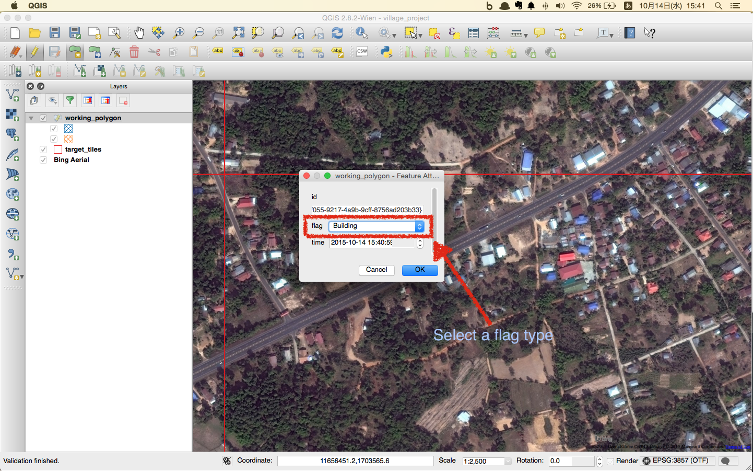

## Digitize next buildings

Digitize all "Building" or "Unknown" features in the tiles that are assigned to you.

## Save

To interrupt your working, click "Save" icon and then, click "Editing mode" icon to finish editing mode.

You can close QGIS application.

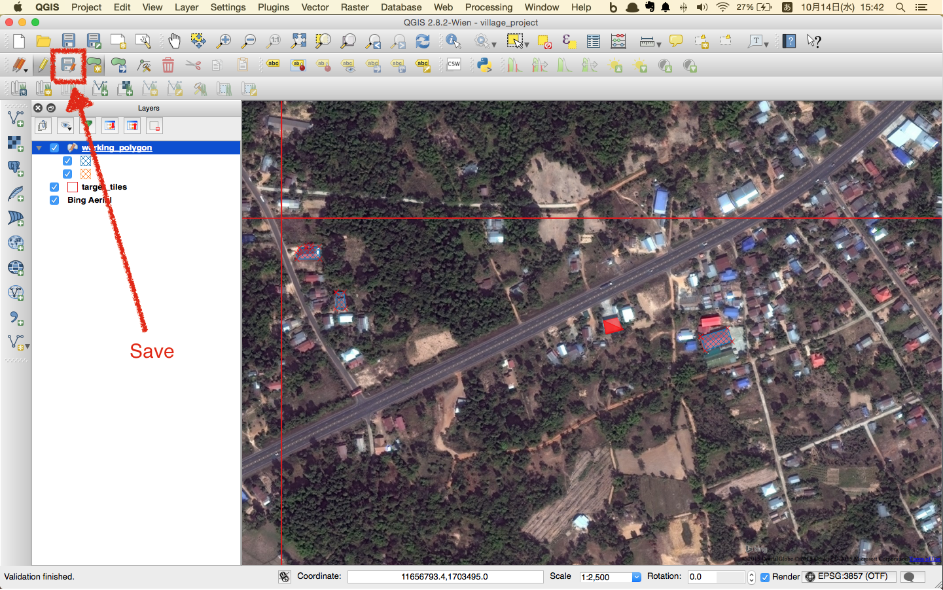

# Examples

1. Digitize only building shape

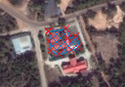

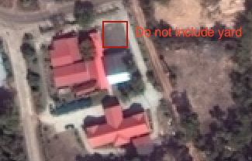

2. If there is no image, report tile ID to administrator.

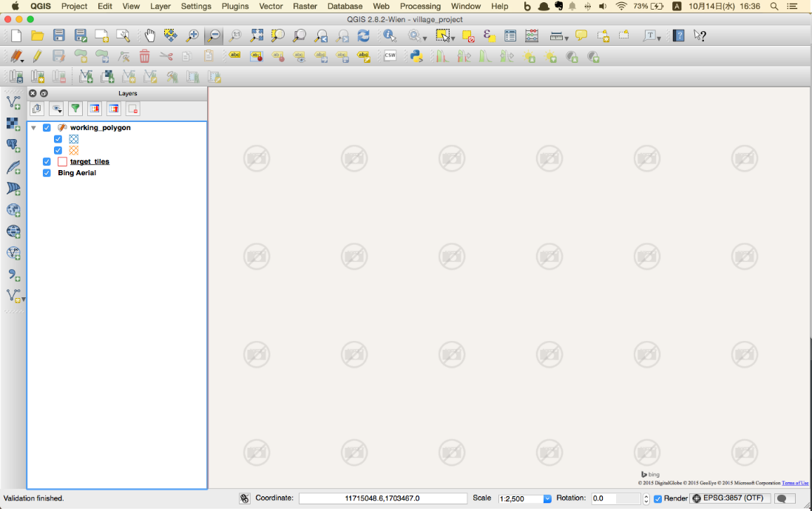

3. Digitize cloud as Unknown

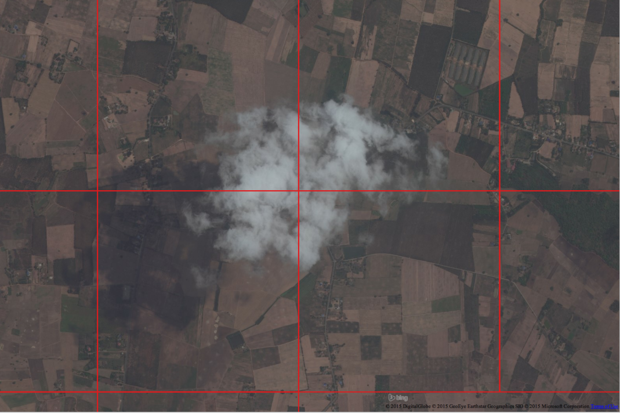

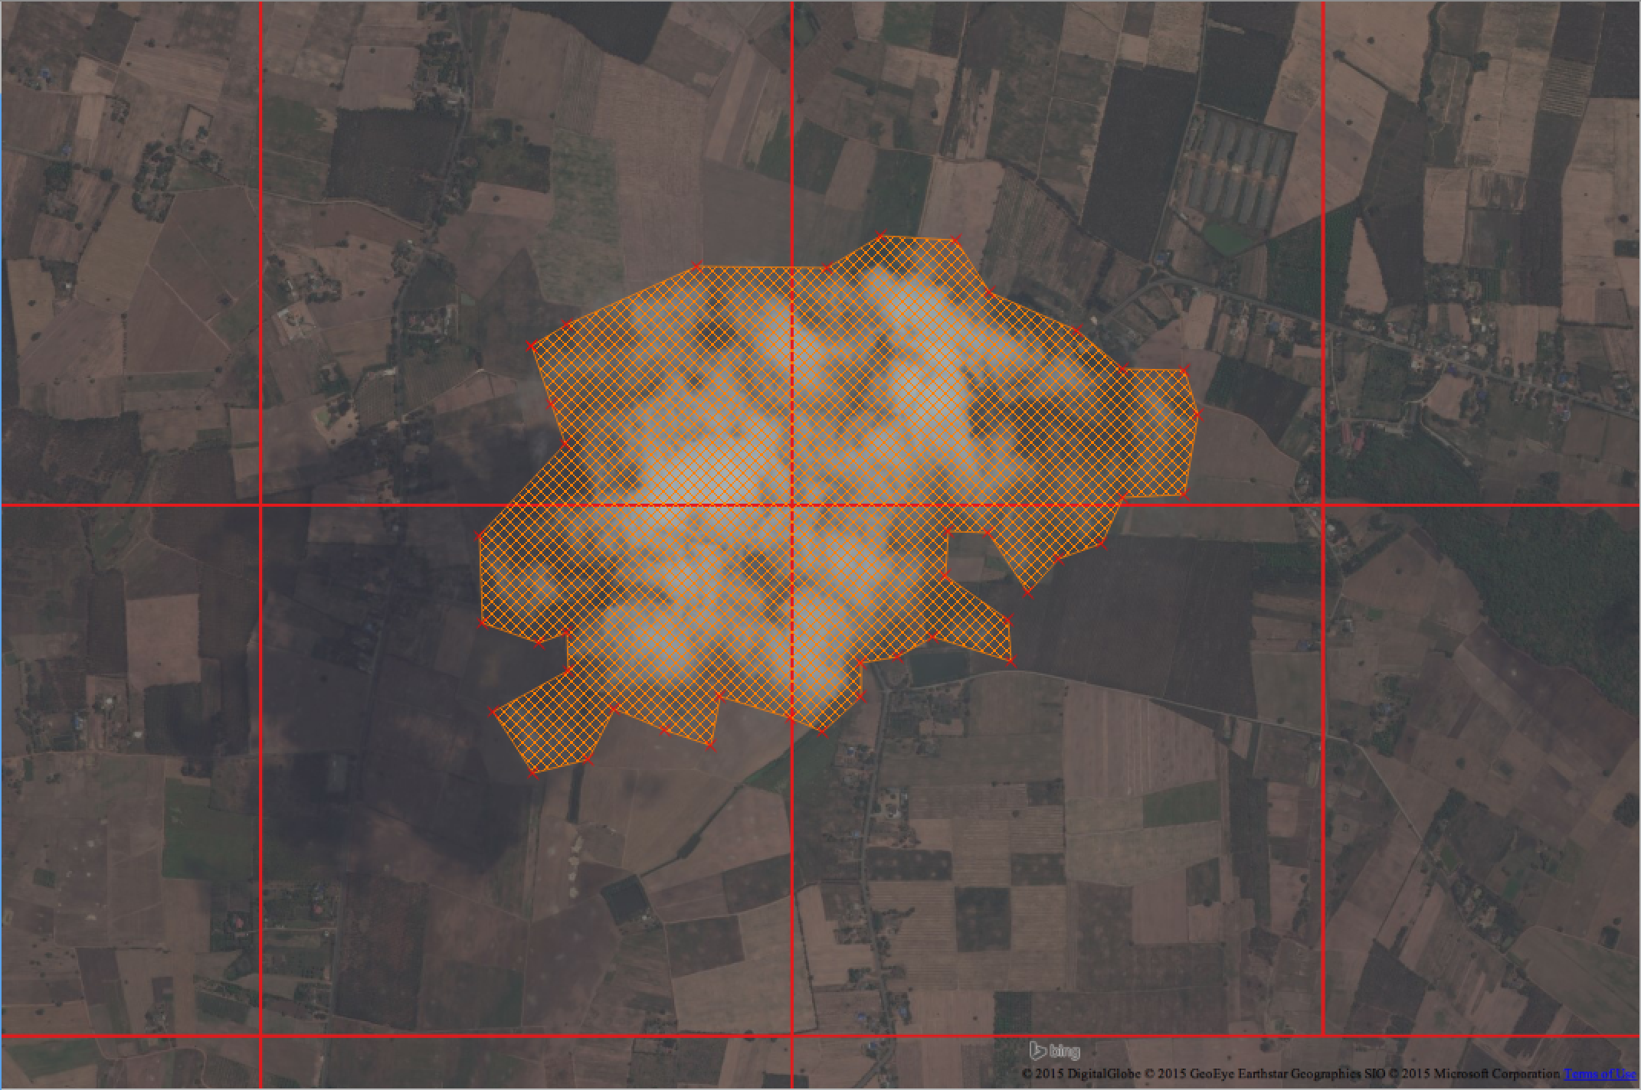

4. You can skip buildings which are located outside of a tile.

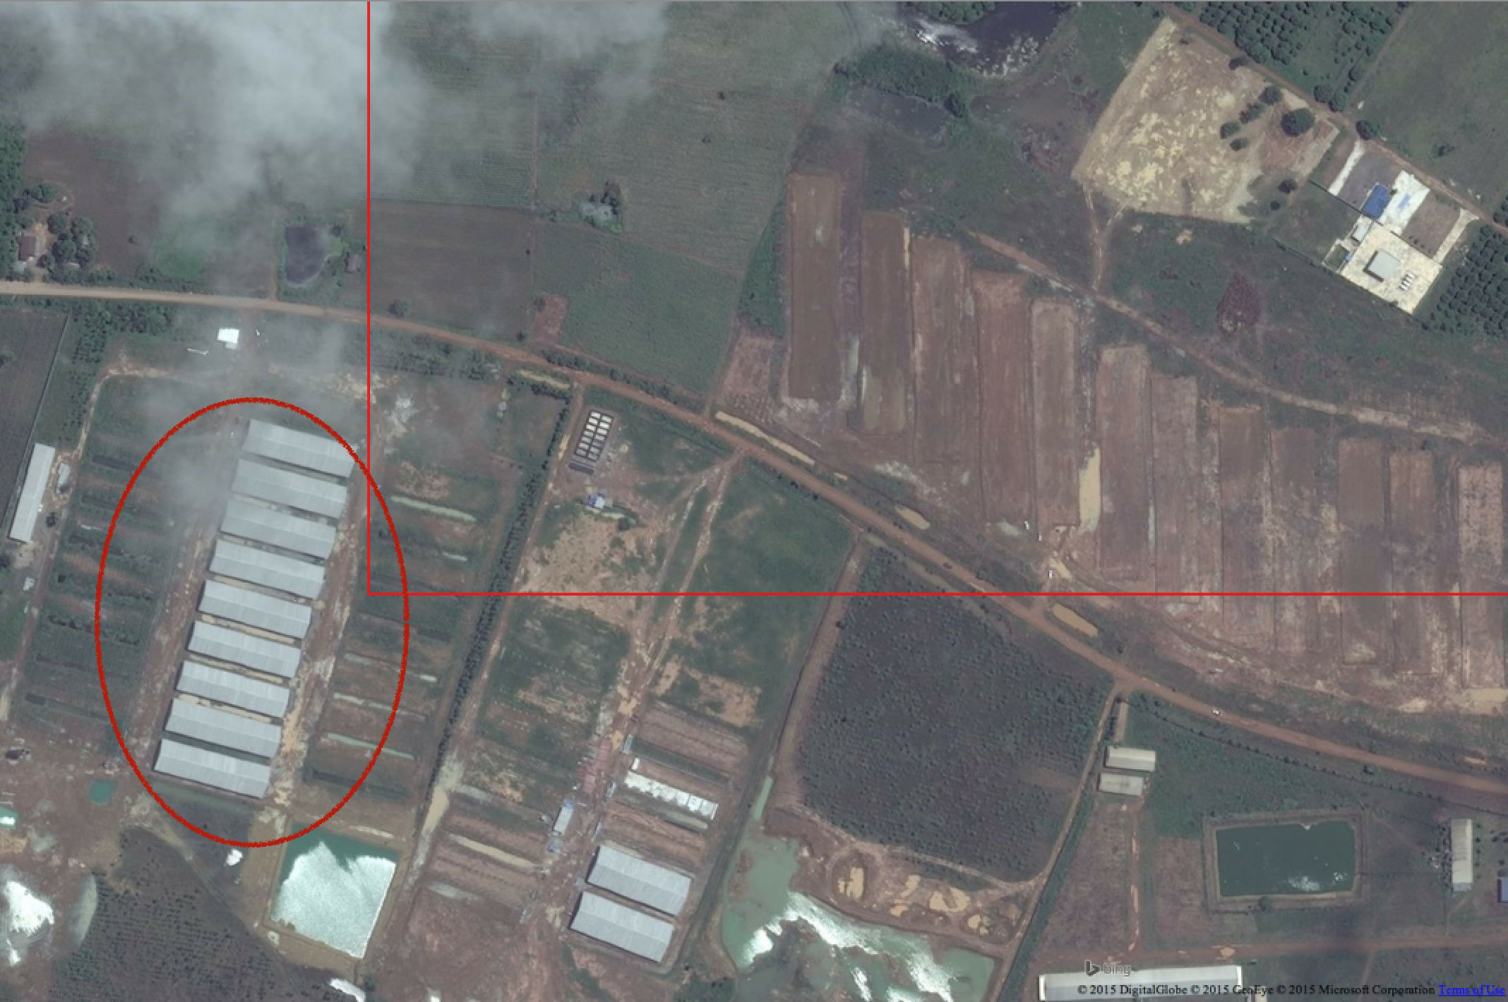

5. Digitize a feature if you think those are buildings!

